Data structure problem

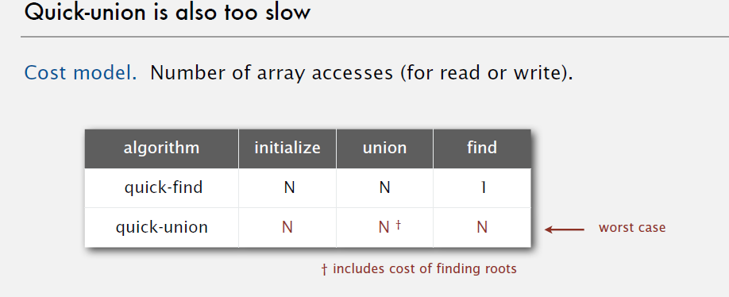

Linear algebra:

1. how to get the derivation of the vector

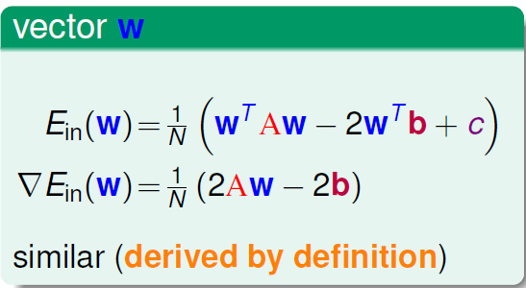

1. pseudo_inverse proof
2. positive definite

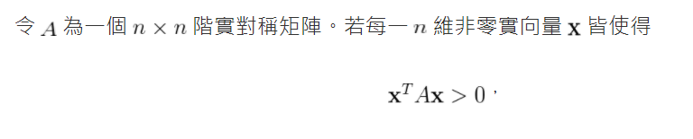

1. 向量微積分

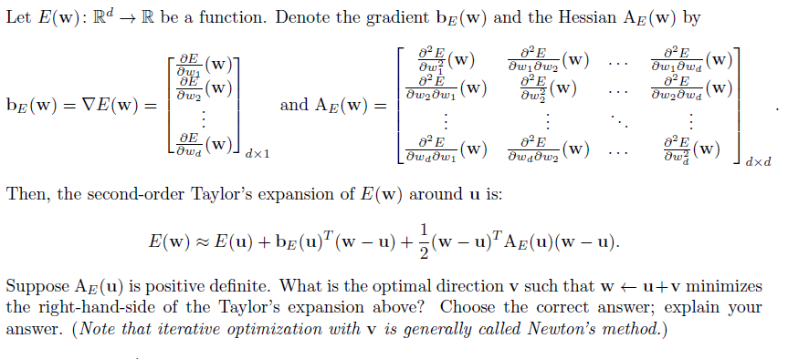

1. gaussian function

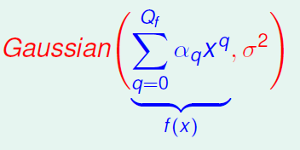

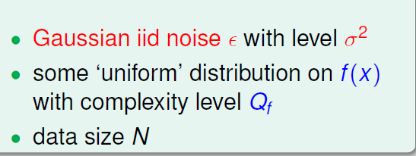

為甚麼是用sigma表示強度

1. Gaussian distribution 的特性:

任意兩個數字從高斯分布取出後相乘的期望值為零???